**Pwyllgor Neuadd Gymunedol**

**Llandyfaelog**

**Community Hall Committee**

Agorwyd Ardal Chwarae Gymunedol newydd Llandyfaelog ddydd Sadwrn 23ain Mehefin 2018 gan y Cyng Mair Stephens. Roedd yr agoriad yn dilyn helfa Eirth Tedi ar gyfer y plant lleol a drefnwyd gan aelodau CFfI Llanismel. Croesawodd Cadeirydd Pwyllgor y Neuadd, Mrs Sarah Walters bawb i'r digwyddiad a mynegwyd diolch i bawb oedd wedi chwarae rhan yn y prosiect.

Ariannwyd y parc newydd trwy grantiau a dderbyniwyd gan Arian i Bawb y Loteri Genedlaethol, Ymddiriedolaeth Elusennol Stadiwm y Mileniwm a rhodd gan Gyngor Cymuned Llandyfaelog.

Y contractwyr oedd yn rhan o'r prosiect oedd SMP Hags, Jason Stiles a Sied Dynion Menai Glanyfferi.

Gwesteion arbennig a wahoddwyd i'r agoriad oedd:

* Cyng Mair Stephens
* Y Cyng. Eifion Jones, Cadeirydd Cyngor Cymuned Llandyfaelog
* Mrs Glenys Lewis, Nantllan, Llandyfaelog a roddodd y tir ar gyfer y parc gwreiddiol.
* Mr John Edwards, gyn Cadeirydd Pwyllgor Neuadd Gymunedol Llandyfaelog, a fu'n allweddol wrth ddarparu'r parc gwreiddiol.
* Cynrychiolwyr y contractwyr dan sylw a chyrff grant eraill.

The new Llandyfaelog Community Play Area was opened on Saturday 23rd June 2018 by Cllr Mair Stephens. The opening followed a teddy bear hunt for the local children arranged by the Members of St Ishmael’s YFC. Hall Committee Chairman, Mrs Sarah Walters welcomed everyone to the event and expressed thanks to all those involved in the project.

The new park was funded via grants received from the National Lottery, Awards for All, The Millennium Stadium Charitable Trust and a donation from Llandyfaelog Community Council.

Contractors involved in the project were SMP Hags, Jason Stiles and Ferryside Men’s Sheds.

Special guests invited to the opening were:

* Cllr Mair Stephens
* Cllr Eifion Jones, Chairman of Llandyfaelog Community Council
* Mrs Glenys Lewis, Nantllan, Llandyfaelog who donated the land for the original park.
* Mr John Edwards a former Chairman of Llandyfaelog Community Hall Committee, who had been instrumental in the provision of the original park.
* Representatives of the contractors involved and other grant bodies.

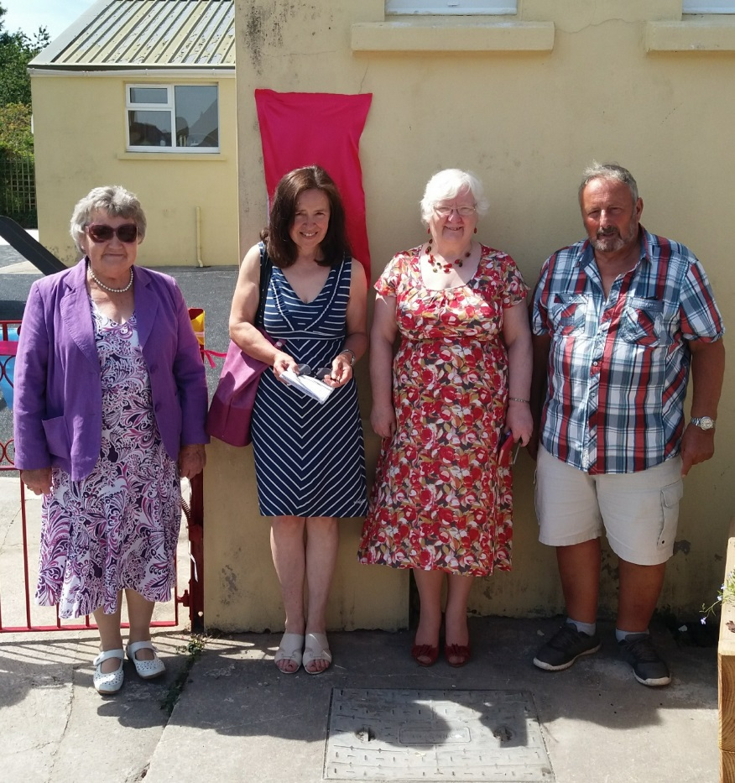

Mrs Glenys Lewis, Mrs Sarah Walters, Cllr Mair Stephens and Mr John Edward

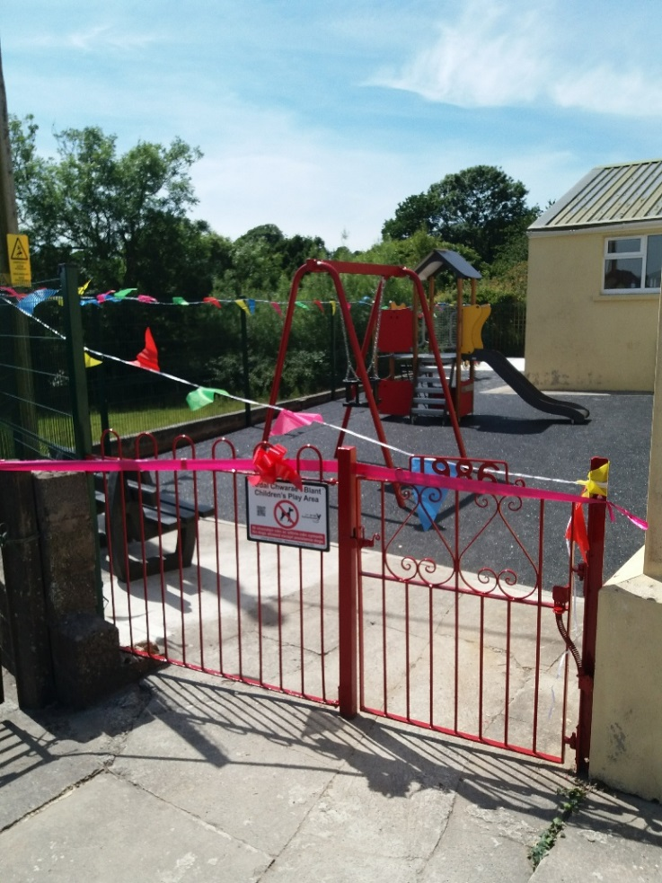

Y Parc Newydd / The New Park

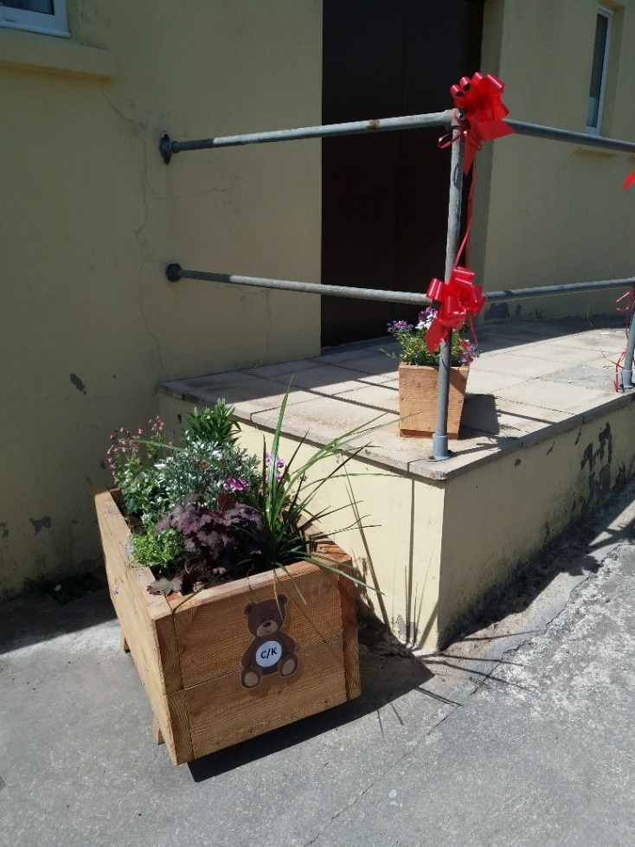

Planwyr Newydd gyda rhan o’r Helfa Eirth Tedi

New Planters with part of the Teddy Bear Hunt

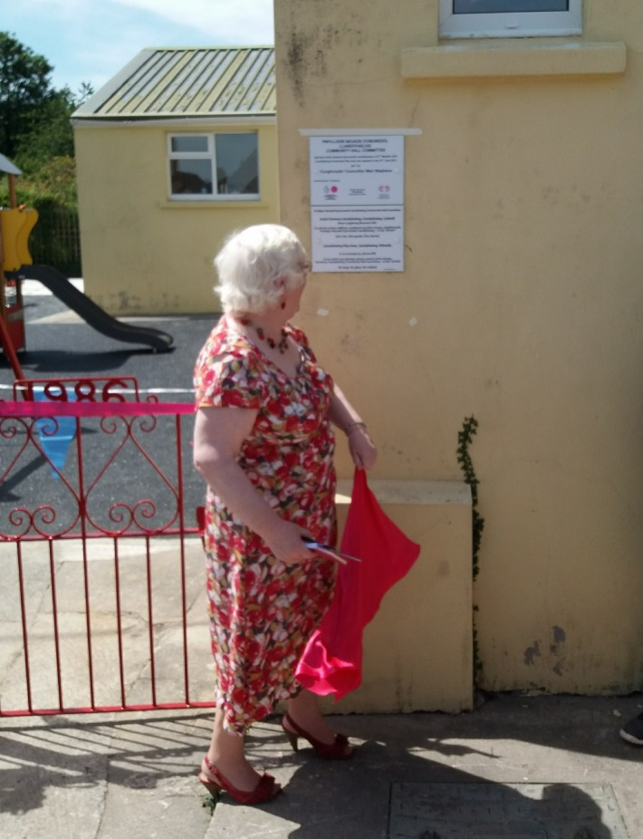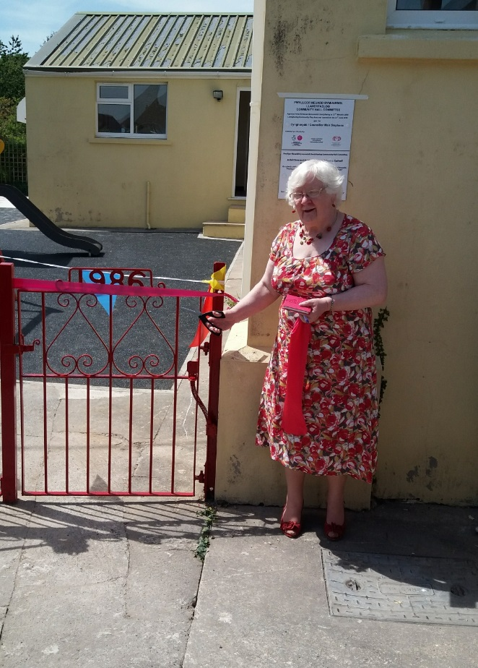

Cyng Mair Stephens yn agor y Parc newydd /

Cllr Mair Stephens opens the new Park

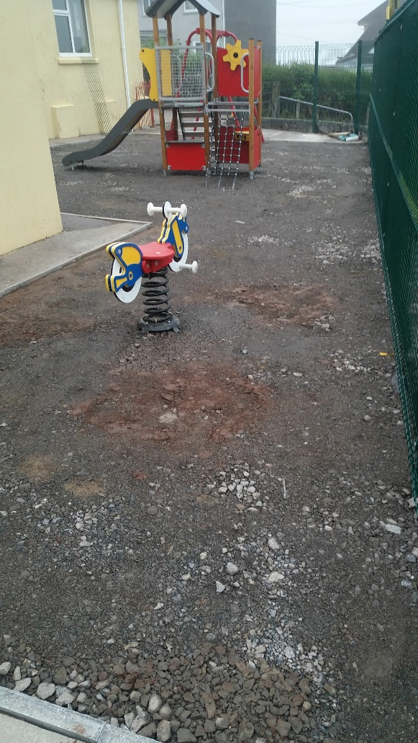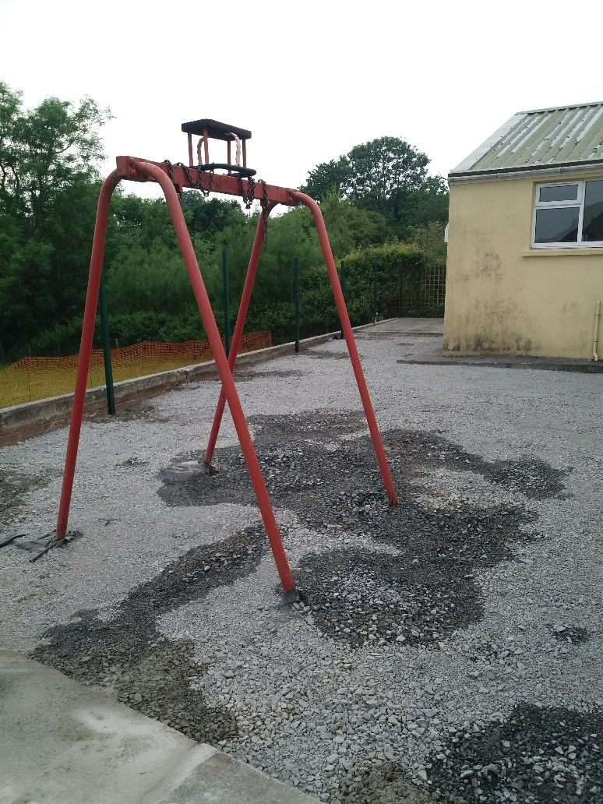

Yn ystod y gwaith / During the works



Y Parc cyn y prosiect / The Park prior to the project